CULTURAL DISTRICT OVERLAY Zoning District

Sec 311

- Purpose Statement
  - The San Angelo City Council has declared that as a matter of public policy, the protection, enhancement, and perpetuation of districts of cultural importance and significance are necessary to promote the economic, cultural, educational, and general welfare of the public. It is recognized that San Angelo represents a unique convergence of time and place that shaped the identity of generations of citizens and produced significant historic, architectural and cultural resources that constitute their artistic heritage. This overlay zone is intended for the following purposes:
    - Protect the cultural areas which represent distinctive elements of San Angelo's historic, architectural, and artistic heritage.
    - Foster civic pride and the preservation of cultural landmarks in this overlay zone.
    - Enhance the district's attractiveness to visitors and promote stimulus to the economy.

- Establishment
  - The Cultural District Overlay (CD) zoning district shall be applicable in all base zoning districts within or partially within the overlay zone. The boundaries for the district shall be aligned with right-of-way lines, property lines, or other identifiable natural or man-made divisions. Allowed use of all property included in the Cultural District Overlay Zone shall continue to be governed by the base zoning district and all regulations pertaining thereto.

III. Map of the Cultural District Area

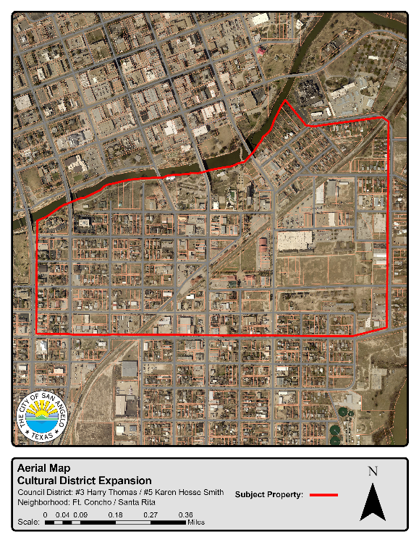
Boundaries are along the Concho River from S. Abe street east to 222 Allen St. then southeast along Allen St. then turning south onto Rust St. then turning west on E Highland St. then north on Abe St. back to the Concho River. All properties and parts of properties will be within the Cultural District (CD) zoning overlay

- Procedure for Zoning Designations

- As an overlay zoning district, the Cultural District Overlay (CD) shall be applicable in all zoning districts, or portions thereof within the district boundaries.
- The area shall be mixed-used from residential household living, neighborhood commercial, office warehouse, office commercial, manufacturing by artisans, and general commercial in nature; see Section 304 G. Cultural District Overlay (CD)
- Cultural District Overlay (CD) is intended to provide opportunities to promote the traditional and cultural heritage of San Angelo as an artistic celebration of cultures which serves a variety of needs in a relatively confined area. The district is intended to include office, retail sales, repair and service businesses, commercial recreation and entertainment, as well as residential uses. Development should complement neighboring activities in the area and promote a variety marketplace concept to enhance our historical and cultural assets of Fort Concho, El Paseo de Santa Angela, Municipal Pool, San Angelo Fine Arts Museum, Welcome Center and the Concho River.
- Short Term Rentals shall be allowed by right within the Cultural District subject to annual review set forth in Section 406.
- Properties designated with a Historic Overlay or within a Historic District shall remain with those designations which fall within the Cultural District boundaries.
- Outdoor storage is limited to 30% of the property
  - All outdoor storage by manufacturing and office warehouse, as well as previous uses of Heavy Commercial (CH) and Light Manufacturing (ML) shall be screened with opaque fencing which can display art and cultural scenes.
  - All outdoor screening or opaque fencing shall be reviewed under Sec. 212 or Sec. 213 as applicable of the Zoning Ordinance.

  - Exceptions:

    - Manufacturing by artisan can be up to 50% outdoor storage to display products for sale
    - Household living
    - Public art on public property
- Parking requirements can be modified under Section 511 in the Cultural District Overlay.
  - Parking lots shall have a landscape buffer of a minimum 5’ from all property lines adjacent to street frontages except for drive approaches
- The Fort Concho Historic District sign regulations Section 12.04.018 are effective in the Cultural District Overlay
- Specific uses and sign types restricted or not allowed in the Cultural District Overlay
  - All Signs in the District shall follow Section 12.04.017 of the Sign Ordinance and Sec. 211 or Sec. 212 as applicable of the Zoning Ordinance.
  - All Banner style signs restricted to 30 days and only 3 times per year and must be reviewed under the Sec. 211 or Sec. 212 as applicable of the Zoning Ordinance.
  - Electronic Message signs
    - Shall be reviewed under Article 12.004 Signs;
    - shall be limited to a 15 square feet in size or smaller;
    - and be dimmed to 250 nits from dusk to dawn;
    - Shall be reviewed under Sec. 212 or Sec. 213 as applicable of the Zoning Ordinance;
  - Intermodal containers shall not allowed;
  - Community Services of itinerant sheltering or alcohol and drug treatment shall not be allowed
- Development Standards in Cultural District Overlay
1.
Standard | Commercial | Residential
Maximum floor area ratio | 3.00 | 2.00
Max height | - | 35
Minimum lot size | 3000 Sq. Ft. | 2500 Sq. ft.
Minimum lot width | 40 ft. | 25 ft.
Minimum lot depth | 50 ft. | 30 ft.
Front yard setback from property line | - | 5 ft.
Side yard setback from property line | - | 5 ft.
Rear yard setback from property line | - | 5 ft.

2. Property uses, signs and buildings which would not conform to the new Cultural District Overlay Zone (CD) would continue to be legal nonconforming until they reach a status applied under Article 6 – Nonconformities and the property has been vacated for two years losing their Building Code occupancy thus triggering a change of occupancy

- Procedures for Design Review
  - Review of applications within the Cultural District Overlay shall follow the procedures set forth under Sec. 211 (Historic Overlay or District) or Sec. 212 as applicable of the Zoning Ordinance.
  - The provisions of the Cultural District Overlay apply specifically to exterior alterations, demolition, construction, moving in or removal of buildings, structures or objects within the boundaries of said overlay zone, on public or private property. Such activity proposed to be undertaken within a Cultural District Overlay shall be subject to approval of Design and Historic Review Commission and all conditions set forth therein, except as otherwise specified in the following sections Section 212 C Review by Planning Director.
  - Public Art in this district shall be the purview of the Public Arts Commission and/or City Council
  - In general design changes should meet the following requirements
    - River Corridor Master Development Plan: 2006 Edition (RCMDP)
    - Possesses significance with respect to history, culture, architecture, archeology, paleontology, or as a natural site with a demonstrable cultural association.
    - Is associated with events that have made a significant contribution to the broad patterns of local, regional, state, national, or international history.
    - Embodies characteristics distinct to a type, period, or method of construction or architecture.
    - Is associated with the lives of persons significant in local, regional, state, national, or international history.
    - Represents a distinctive and familiar visual feature of a neighborhood or of the city.
    - Represents the works of a master designer, architect, builder, or craftsman.

Section 304
G. CD (Cultural District Overlay) The Cultural District Overlay is intended to provide opportunities to promote the traditional and cultural heritage of San Angelo as an artistic celebration of cultures which serves a variety of needs in a relatively confined area. The district is intended to include office, retail sales, repair and service businesses, commercial recreation and entertainment, as well as residential uses. Development should complement neighboring activities in the area and promote a variety marketplace concept to enhance our historical and cultural assets of Fort Concho and the Concho River.

Sec 313 Use Table
All of the use categories listed in the Table below are explained in Sec. 311 through 317. The second column of the use table contains an abbreviated explanation of the respective use category. If there is a conflict between the abbreviated definition and the full explanation in Sec. 311 through 317, the provisions of Sec. 311 through 317 shall control.

